**FIREWALL EXPLORATION LAB/ASSIGNMENT REPORT**

**Name – Subhashini Thirumala**

**Student Number – 700740834**

**email** [**ID-Sxt08341@ucmo.edu**](mailto:ID-Sxt08341@ucmo.edu)

With reference to the Lab instructions, I have done all the tasks given in the instructions along with lab manual. Detailed report is here under:

**LABSETUP:**

Screenshots of Brining up a Terminal in Ubuntu 20.04 VM and changing directory to Lab setup folder in the terminal, also dcbuild & dcup commands to bring up the container.

**Terminal Screenshots of building docker container**

**TASK 0: WE** need to block one additional site which is www.ucmo.edu. Added the highlighted statement shown below to the docker-compose.yml file for the Router container. Saved the modified yml file and restarted the Router container.

**Testing the connection to** [**www.ucmo.edu**](http://www.ucmo.edu)

**Task 1: STATIC PORT FORWARDING**

**Establishing tunnel from B1 to B**

**Establishing detour from A , telnet from A1 to A**

1. **THERE ARE 3 TCP CONNECTIONS ESTABLISHED DURING THIS. TELNET, SSH AND TELNET AGAIN. A1 🡪A 🡪B 🡪 B1.**
2. AS THE PORT 3333 IS AVAIBLALE FOR THE CONNECTION AND ALSO BY **USING 0.0.0.0 WE CAN DETOUR FROM A CONNECTION INITIATED FROM A1. AS IT HAS MANY INTERFACES WE NEED TO USE 0.0.0.0 TO ESTABLISH ONE SPECIFIC CONNECTION TO DETOUR.**

TASK 2.1: SETTING UP DYNAMIC PORT FORWARDING:

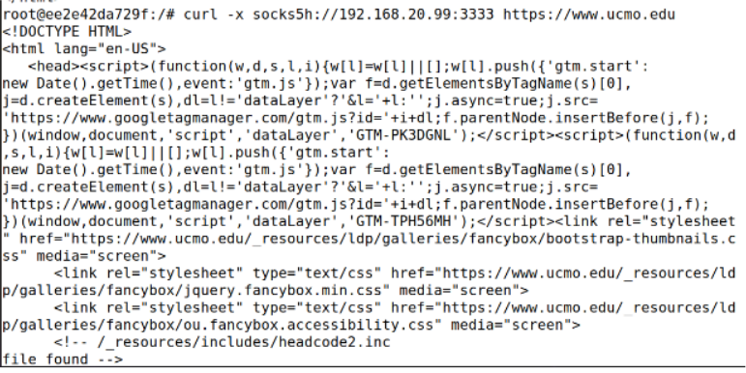

**TASK 2.2: TESTING THE TUNNEL USING BROWSER**

**TASK 2.3: WRITING A SOCKS CLIENT USING PYTHON:** In this task, we implement a very simple SOCKS client program using Python

**Tunneling establishment**

**Netcat establishment**

**Execution of python program**

**Output:**

**We are able toaccess the** [**http://www.example.com**](http://www.example.com) **while executing the python program on B, B1 and B2 as well.**

**TASK 3.1: BYPASSING INGRESS FIREWALL: We have established VPN tunnel between A and B with B as VPN server. As we created VPN tunnel and proper ip routing entries are maintained in the host A hence we are able to telnet B,B1 and B2.**

**Establishing Telnet connection from A to B1**

**TASK 3.2: BYPASSING EGRESS FIREWALL: We have established VPN tunnel between B and A with A being VPN Server. As we created VPN tunnel and proper ip routing entries are maintained in the host B hence we were able to access www.example.com**

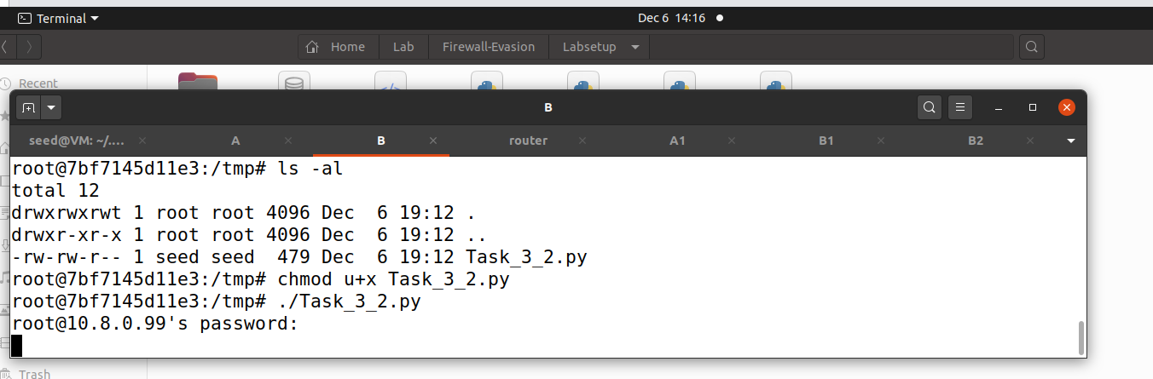

**END OF THE REPORT**